Post-Quake Farming
4 October 2019

AGENDA

10:00 am Steepdown Yard (Blunts Road, Inland Road)
Discuss the objectives for the day and introduction to Tony Blunt + Kurt Bartrum

10:15 am Car pool to top of Steepdown

10:30 am Forestry on farm (Tony Blunt + Dave Janett)
Discuss history of property, regeneration of native bush and current plantings
Future carbon claims and/or plantings to be undertaken, eligibility of land, 1 BT grants.

11:15 am Alternative income sources (Tony Blunt, Farm Owner)
Alternative income sources associated with forestry and native bush

11:30 am Travel back to Steepdown Yard

11:45 am Carbon Lookup Tables
Annuity calculation worksheet provided for farmers with varying area and species

12:00 pm Summary of morning and any final questions
Q & A session

12:15 pm Travel to Lynton Downs

12:30 pm Lunch

1.15pm Lynton Downs (Kurt Bartrum, Farm Manager)
Introduction to Lynton Downs and the commercial forestry business (Kurt)

1.30pm Travel to Forestry Site (Jeremy Patterson-Green, Tasman Forestry Management Ltd)
Harvesting, species harvested and markets, typical income and costs, logging now vs 20 years ago and future considerations

3.00pm Woolshed Discussion (Adrian Loo – Forest Management Ltd)
Pre/Post 1990 plantings – Carbon / Averaging for exotics
Climate Risk
1BT Grants
How do I get started?
Open question session – (Tony, Kurt, Jeremy, Adrian)

4.00pm BBQ and Refreshments (Kaikoura Teen Ag)

Steepdown Farm Summary

Current Farming System
- 798 ha (500 ha effective + 298 ha bush)
  - 70 ha cultivatable flats
- 1,400 breeding ewes
- 400 ewe replacements
- 90 breeding cows
- 15 R2yr heifers
- 31 R1yr heifers

History
- A large area of native bush was cleared in the late 1970’s under the government’s land development scheme
- Bush regeneration started to come away post 1989 (see following pictures)
- A farm system change was carried out in 1998 once Tony returned home to the farm
- First meeting with ECAN in 2019 to discuss forestry and develop a claim

Emissions Trading Scheme
- Currently 155 ha under scheme earning an annuity
- 35 ha of new poplar poles that will qualify in next application
- In the process of applying to add an additional 70 ha to the scheme
- Targeting 300 ha under the scheme in future

Current and Future Planting
- Recently finished planting poplar poles on 15 ha of unstable hill ground
- Another 20 ha identified as needing poles
- In discussion to try and get funding for 40 ha of additional plantings under ‘potential enhanced planting’ scheme

Emissions Trading Scheme Revenue
- Currently earning circa. $60,000/year with the current qualifying area in the scheme
- Would increase to circa. $120,000/year if target area qualifies for scheme

Honey
- Currently renting out hive sites for $20,000/year
  - Across 3 x sites (80 hives total)
- Mainly Kanuka currently
- Looking at option for planting Manuka under ‘potential enhanced plantings’ scheme
  - Would help with spreading income risk as the flowering dates are slightly different

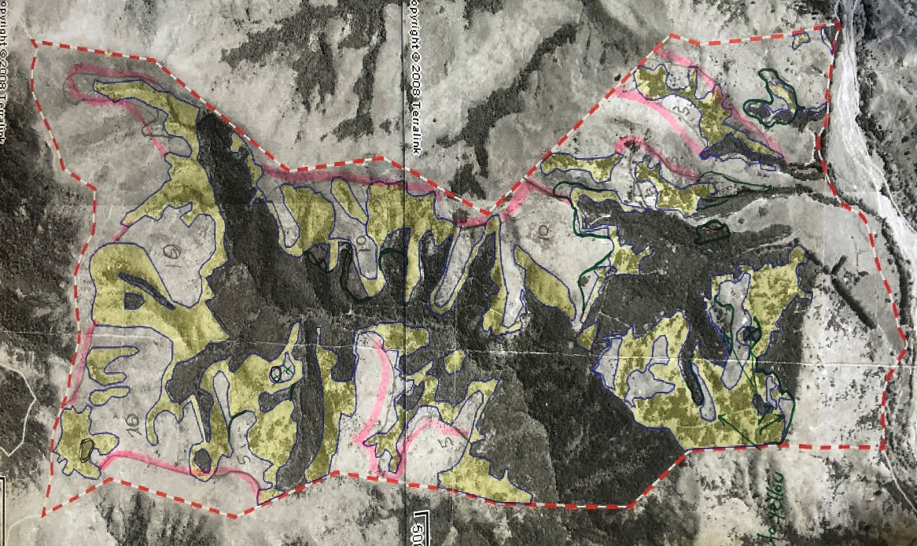
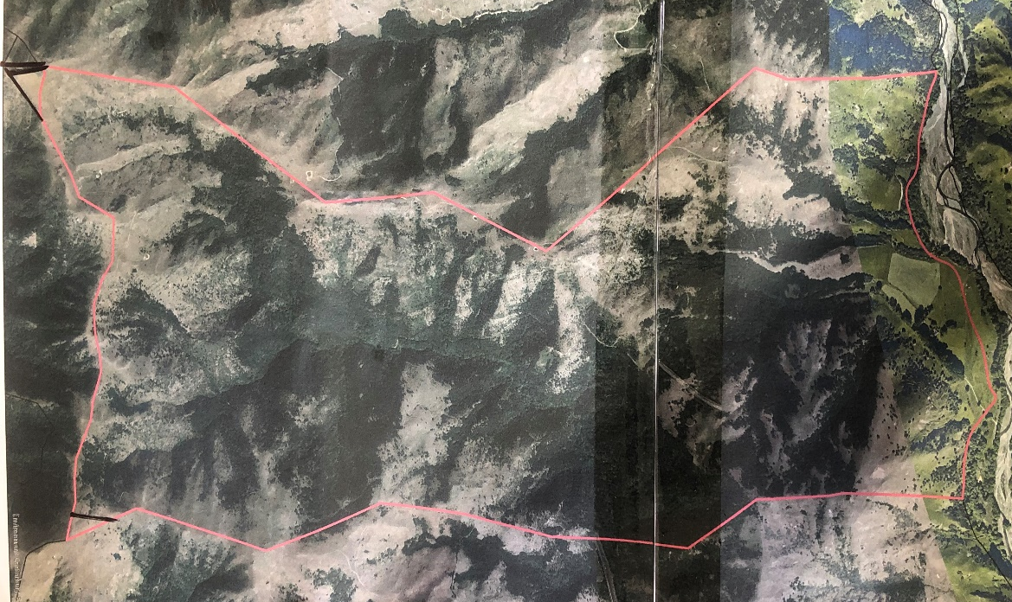
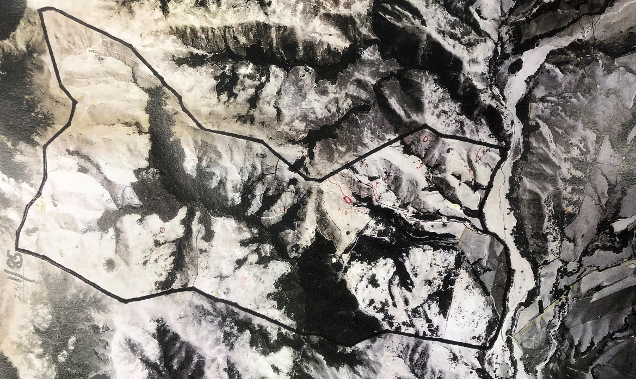
Figure 3: Steepdown area in emissions trading scheme
Figure 2: Steepdown land cover - 2008
Figure 1: Steepdown land cover - 1985

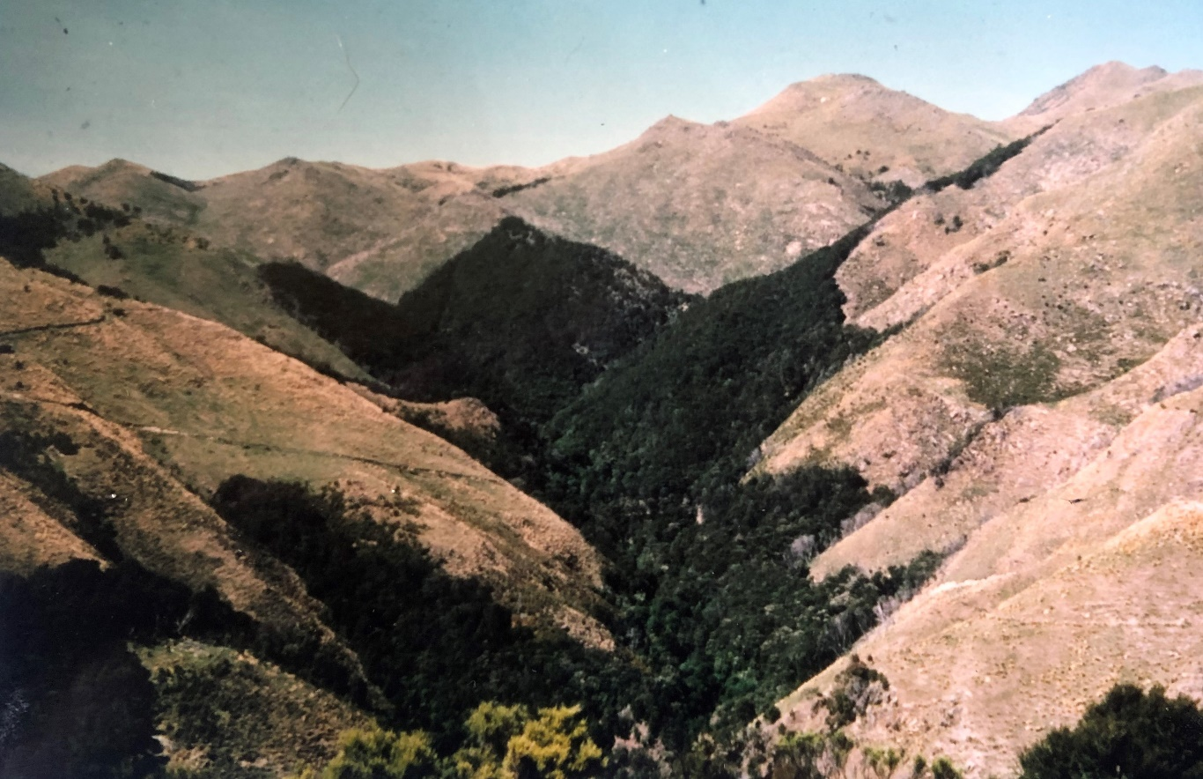
Figure 5: Comparative land cover - 2019
Figure 4: Land cover - 1984

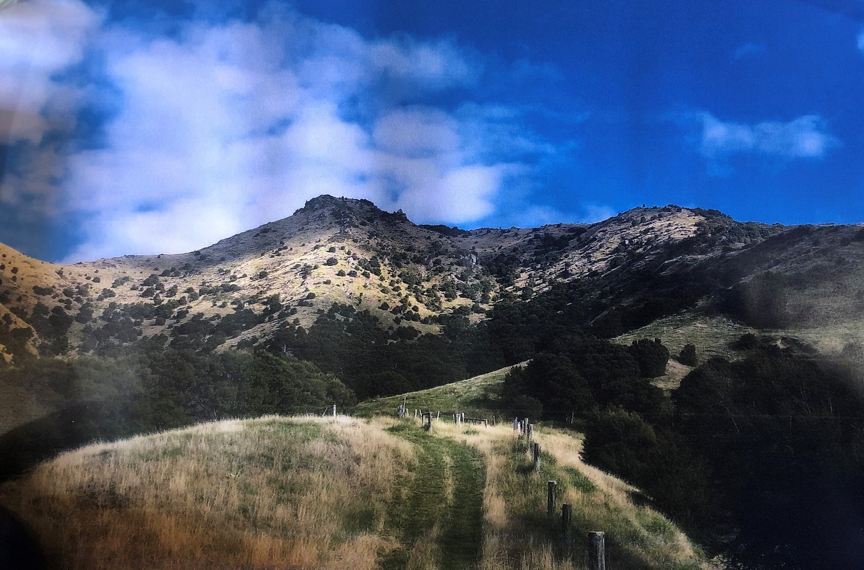
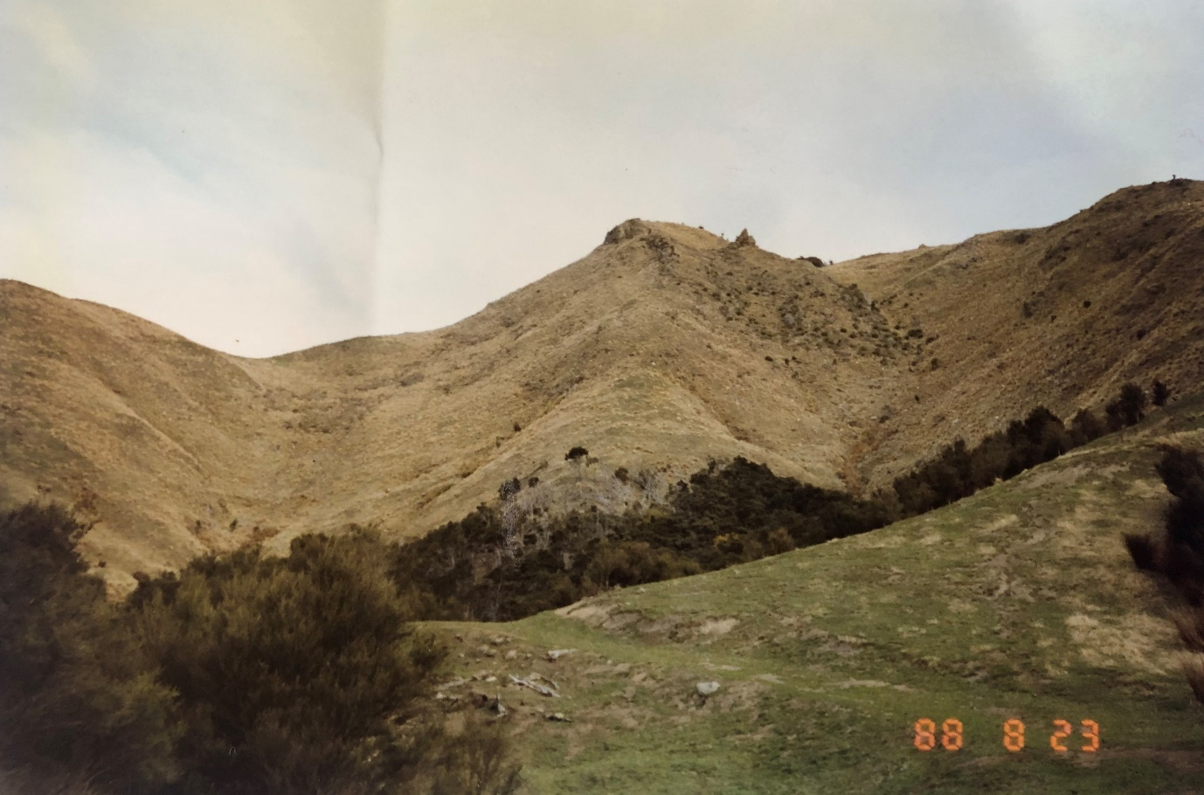
Figure 7: Comparative land cover - 2019
Figure 6: Land cover - 1988

Figure 8: 35 ha Poplar planting carried out in 2019

Annual Lookup Table for Sequestered Carbon (ton/hectare/year) for Post-1989 Forest Land

Year | Douglas-fir | Exotic Softwoods  (Poplar) | Exotic Hardwoods | Indigenous Forest  (Manuka/Kanuka) | Pinus Radiata  (Pine Tree)
0 | 0 | 0 | 0 | 0 | 0
1 | 0.1 | 0.2 | 0.1 | 0.6 | 0.2
2 | 0 | 0.8 | 2.9 | 0.6 | 0.8
3 | 0.3 | 2 | 10 | 1.3 | 1
4 | 0.6 | 9 | 21 | 2.1 | 3
5 | 1 | 14 | 29 | 3.2 | 10
6 | 1 | 19 | 35 | 4.3 | 16
7 | 4 | 18 | 39 | 5.4 | 22
8 | 13 | 14 | 39 | 6.5 | 23
9 | 13 | 10 | 38 | 7.6 | 25
10 | 17 | 8 | 37 | 8.6 | 24
11 | 19 | 11 | 35 | 9.6 | 14
12 | 21 | 12 | 34 | 10.5 | 11
13 | 23 | 14 | 31 | 11.2 | 8
14 | 25 | 15 | 30 | 11.8 | 12
15 | 27 | 16 | 28 | 12.2 | 16
16 | 28 | 17 | 26 | 12.6 | 19
17 | 29 | 17 | 24 | 12.7 | 21
18 | 31 | 17 | 24 | 12.8 | 23
19 | 15 | 18 | 22 | 12.7 | 25
20 | 18 | 17 | 21 | 12.4 | 26
21 | 21 | 17 | 20 | 12.2 | 26
22 | 24 | 17 | 19 | 11.7 | 27
23 | 24 | 16 | 19 | 11.3 | 27
24 | 27 | 16 | 17 | 10.8 | 28
25 | 27 | 15 | 17 | 10.3 | 27
26 | 27 | 14 | 15 | 9.6 | 26
27 | 9 | 15 | 15 | 9.1 | 27
28 | 23 | 14 | 13 | 8.5 | 27
29 | 25 | 14 | 13 | 7.9 | 27
30 | 25 | 13 | 11 | 7.4 | 27

Annual Carbon Value ($/hectare/year) for Post-1989 Forest Land at a $25 per NZU carbon price

Year | Douglas-fir | Exotic Softwoods | Exotic Hardwoods | Indigenous Forest | Pinus Radiata
 |  | (Poplar) |  | (Manuka/Kanuka) | (Pine Tree)
0 | $0 | $0 | $0 | $0 | $0
1 | $3 | $5 | $3 | $15 | $5
2 | $0 | $20 | $73 | $15 | $20
3 | $8 | $50 | $250 | $33 | $25
4 | $15 | $225 | $525 | $53 | $75
5 | $25 | $350 | $725 | $80 | $250
6 | $25 | $475 | $875 | $108 | $400
7 | $100 | $450 | $975 | $135 | $550
8 | $325 | $350 | $975 | $163 | $575
9 | $325 | $250 | $950 | $190 | $625
10 | $425 | $200 | $925 | $215 | $600
11 | $475 | $275 | $875 | $240 | $350
12 | $525 | $300 | $850 | $263 | $275
13 | $575 | $350 | $775 | $280 | $200
14 | $625 | $375 | $750 | $295 | $300
15 | $675 | $400 | $700 | $305 | $400
16 | $700 | $425 | $650 | $315 | $475
17 | $725 | $425 | $600 | $318 | $525
18 | $775 | $425 | $600 | $320 | $575
19 | $375 | $450 | $550 | $318 | $625
20 | $450 | $425 | $525 | $310 | $650
21 | $525 | $425 | $500 | $305 | $650
22 | $600 | $425 | $475 | $293 | $675
23 | $600 | $400 | $475 | $283 | $675
24 | $675 | $400 | $425 | $270 | $700
25 | $675 | $375 | $425 | $258 | $675
26 | $675 | $350 | $375 | $240 | $650
27 | $225 | $375 | $375 | $228 | $675
28 | $575 | $350 | $325 | $213 | $675
29 | $625 | $350 | $325 | $198 | $675
30 | $625 | $325 | $275 | $185 | $675

‘One Billion Trees’ Programme

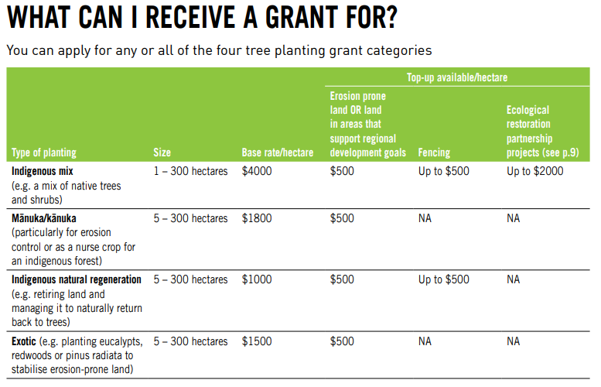
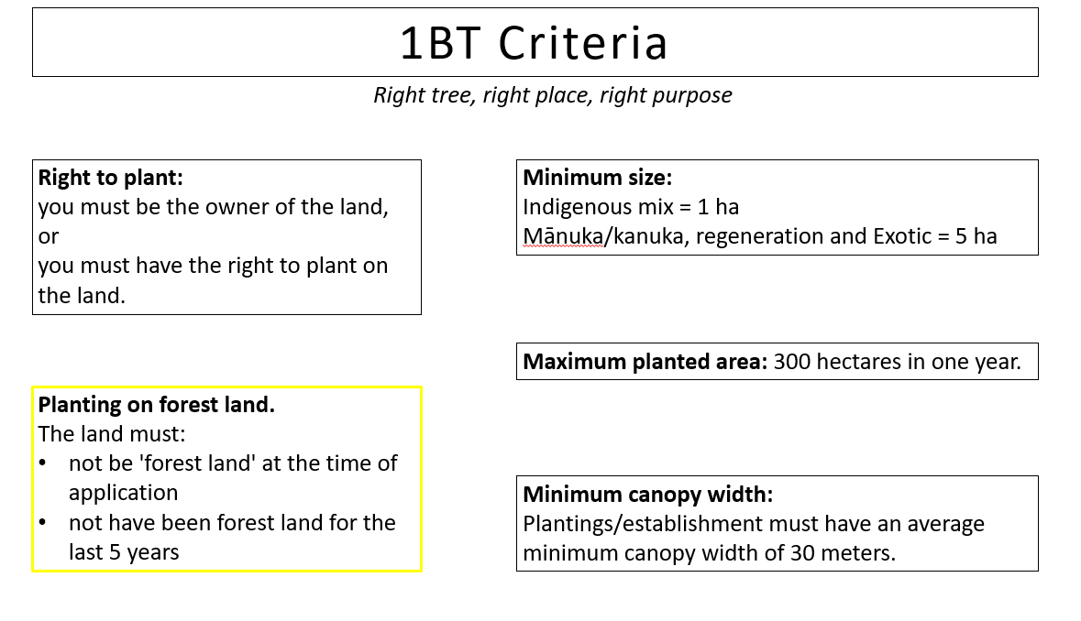

Lynton Downs Summary

Current Farming System
- 3,555 ha total
  - 900 ha effective
  - 249.9 ha in forestry
  - 2,405 ha regenerating native and rocks/alpine growth
- 3,300 breeding ewes
- 950 hoggets
- 190 M/A cows
- 45 heifer replacements

History of Forestry
- Heavy clay country, prone to slipping with low/no fertiliser history and some weeds
- Family interest in forestry, an English forester came to Lynton Downs in the early stages of planting and put some species in such as Conifer, Corsican Pine and Cedar
  - Hard to find markets for smaller amounts of these species
  - Have now gradually changed back to a mix of predominately Douglas fir and Radiata
- First plantings in the 1960’s
- Under a rotation of planting to milling

Forest Management
- The present practice is to plant a mix of Douglas fir and Radiata
- Douglas fir on a 50-year rotation. Planted on the steeper country as it is milled less often
  - No pruning cost
  - 600 trees/ha for smaller branches at harvesting
  - Weed control is higher due to slower growing until canopy closure
- Radiata Pine aiming for 350-400 trees/ha
  - 3 stage pruning and thinning costs
- Prime Pine Kaikoura normally only take smaller amounts on a weekly basis

Risks for Lynton Downs
- Fire
- Wind, opening up faces to exposed trees at milling in a rotation
- Snow damage at high altitudes
- Costs of harvest and cartage
- Weeds

Estimated Establishment Costs – cost structure per ha from cutover to harvest ready

Species | Root raking | Planting | Spot spraying | 3 lifts/pruning | Weed Control | Total/ha
Douglas fir | $875 | $360 | $138 |  | $100 | $598
Radiata | $875 | $270 | $92 | $2,600 | $100 | $3,062

Nb: Includes tree stocks, Douglas fir @ 600 seedlings/ha, Radiata @ 450 seedlings/ha, Weed control 1-3 years (estimate)

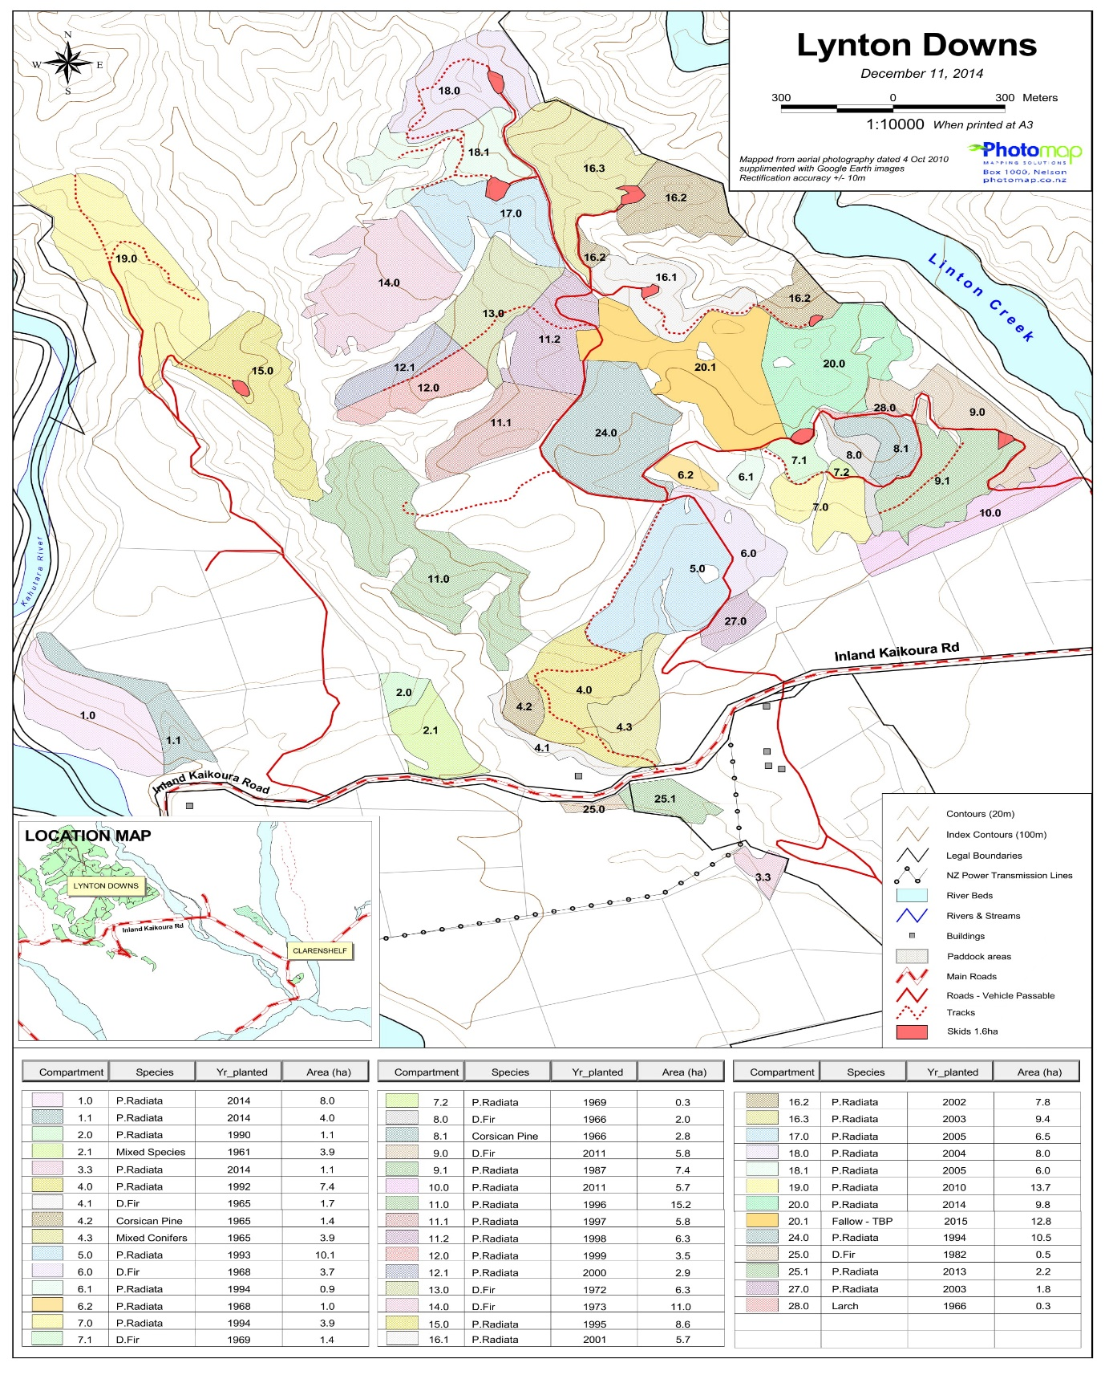

Species | Area (ha)
Douglas fir | 32.4
Pinus Radiata | 174.6
Mixed Species | 3.9
Corsican Pine | 4.2
Mixed Conifers | 3.9

